**LCHS Trust Induction** 

This booklet has been designed to support you and your manager with other useful knowledge and information in addition to the induction course and will support your local workplace induction.

**Staff Intranet - you will register for this on Day 3**

<https://staff.lincolnshirecommunityhealthservices.nhs.uk/>

Please take some time to explore this site, as it contains all of the key information, guidance, useful contacts and Trust news, you will register for this and be shown some aspects on your IT essentials on Day 3.

All LCHS policies can be found on the public website

<http://www.lincolnshirecommunityhealthservices.nhs.uk/Policies-and-Guidelines>

**Safeguarding**

Copies of safeguarding referral forms and processes can be found in the safeguarding adult or children sections within patient safety page of the website.

If you are concerned about the immediate safety or wellbeing of an individual please ring 999 without delay

For urgent Adult referrals you may also ring 01522 782155,

And complete the referral from

Safeguarding Children referrals 01522 782111 and complete the referral form

All Lincolnshire Safeguarding board eLearning for Adults and Children can be located on.

[www.lincolnshire.gov.uk/professionals/support/training12463.article](http://www.lincolnshire.gov.uk/professionals/support/training12463.article)

**https://staff.lincolnshirecom https://staff.lincolnshirecommunityhealthservices**

**Local Induction**

You will receive a local induction In your workplace, during this complete the induction checklist, it should be signed once completed by you and your manager. It will include:

* Local Health and Safety information including fire safety and lone working arrangements
* Local Record Keeping training
* Hand Hygiene assessment
* To complete a local induction checklist (attached to this hand out) and ensure this is returned to workforces Services
* Make arrangements for follow up meetings during your probationary period
* Be advised of the name of the person to report your clinical supervision activity to

**Further Training**

Courses and training for all staff will be identified via your appraisal and added to the service Training Needs Analysis [TNA] Courses will be prioritised according to service need and future service development.

**Wider Workforce bands 1-4**

The wider workforce is highly valued in LCHS. Training is available and funding is accessed from other sources. Courses and training should be identified via your appraisal and added to the service Training Needs Analysis [TNA]. Courses will be prioritised according to service need and future service development.

**Clinical staff Learning Beyond Registration [LBR]**

LCHS is part of the East Midlands Deanery and training is available within this area. More information can be found in the Learners portion of the Education and Training section on the website. Please read and follow the LBR application process. Failure to do so can result in failure to gain places and /or being personally responsible for course fees.

**Preceptorship**

LCHS runs a programme for all newly qualified staff. Your manager will advise you of your mentor and you will be booked onto the programme if you are a preceptee.

**Medicines Management**

The medicines management section can be found within Patient Safety on the staff website. This includes a list of current PGDs for services and links to the relevant policies. Anyone working under PGD must complete the PGD eLearning prior to signing and being assessed as competent.

eLearning via ESR: 818 Patient Group Directions

**Prescribers** should contact Karen Leggett, Medicines Support Officer to arrange for collection of prescription pads and the required processes which should be followed.

[Karen.leggett@lincs-chs.nhs.uk](mailto:Karen.leggett@lincs-chs.nhs.uk) 07580130531

**Lorna Adlington Medicines Optimisation Lead**

[lorna.adlington@lincs-chs.nhs.uk](mailto:lorna.adlington@lincs-chs.nhs.uk) 01507 608342

**Supervision**

LCHS uses a behavioural based appraisal model called “Your Performance Matters “

Please take time to look at the details which are available on the website in the ‘Staff Room’ area. All staff can access management supervision in the form of one to one meetings. You should expect a series of meetings during your probationary period. It is recommended that you organise these dates during local induction.

**Clinical Supervision**

**All clinical** staff are required to undertake Clinical Supervision a minimum of 4 times per year. All clinical staff should complete the clinical supervision training. Please record this via the clinical supervision section on the website; **It is the supervisee’s responsibility to record** this activity, if you are unsure ask your line manager

From the home page on the website click on the link

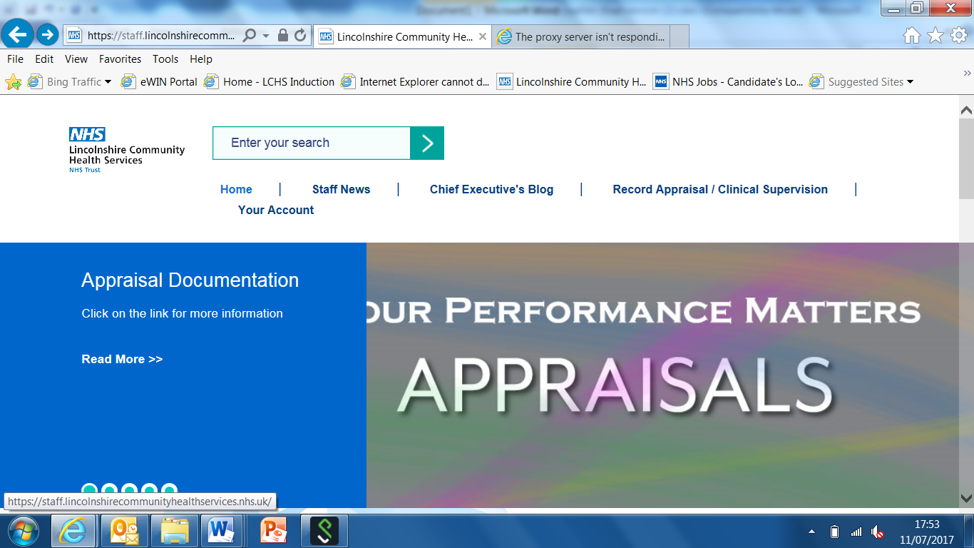

Statutory Safeguarding Supervision is undertaken in addition to Clinical Supervision, it is the supervisee’s responsibility to report and should be reported on by the same method.

**E Learning**

Clinical staff are required to complete ELearning on the following topics; joining instructions are attached below.

1. Anaphylaxis
2. Self Neglect
3. Parkinson’s Disease awareness
4. Multiple Scleroisis awareness
5. Users of PGD’s s; this must be completed prior to sigjing PGD’s and using them ; eLearning via ESR: 818 Patient Group Directions

**Anaphylaxis eLearning for ALL Clinical Staff**

1. Access the staff intranet
2. Click on ‘Patient Safety’

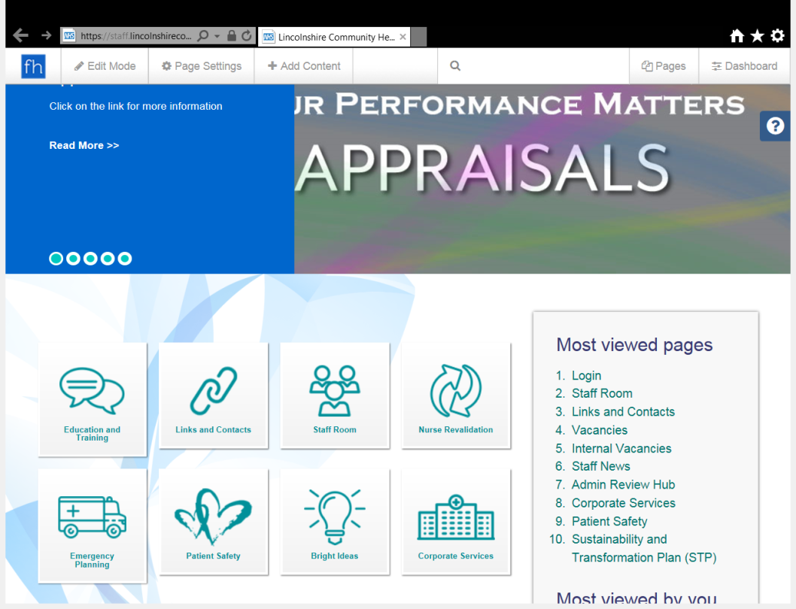

1. Open Deteriorating Patient & Resuscitation

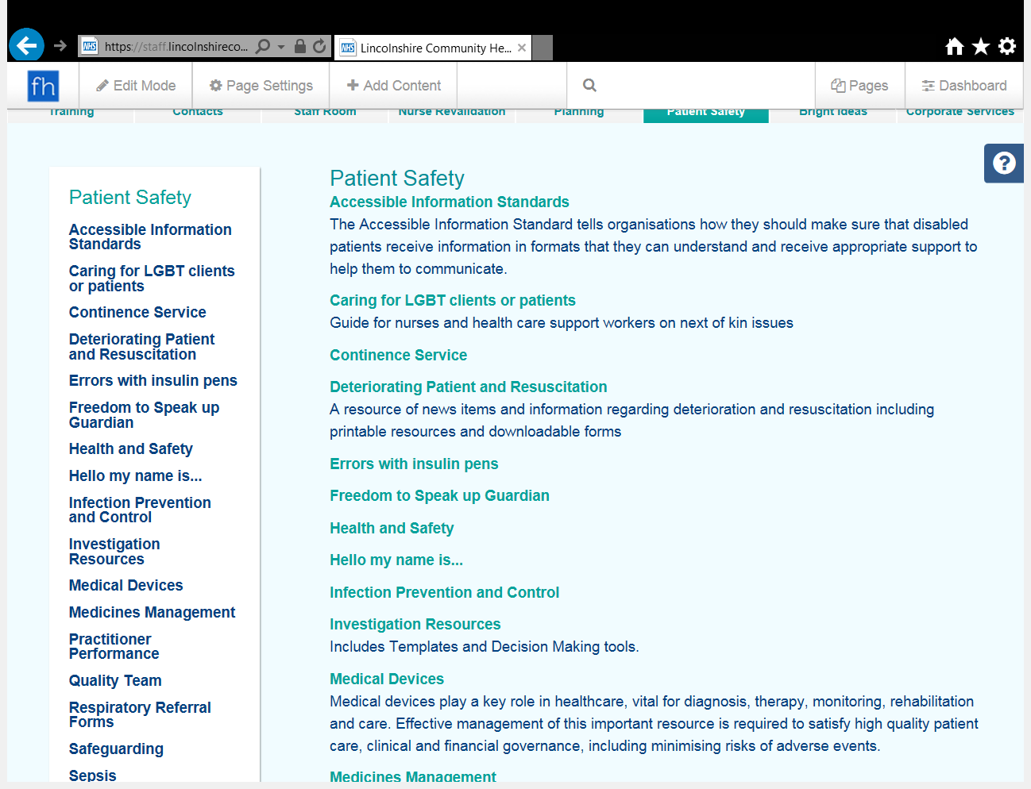

1. Click Anaphylaxis

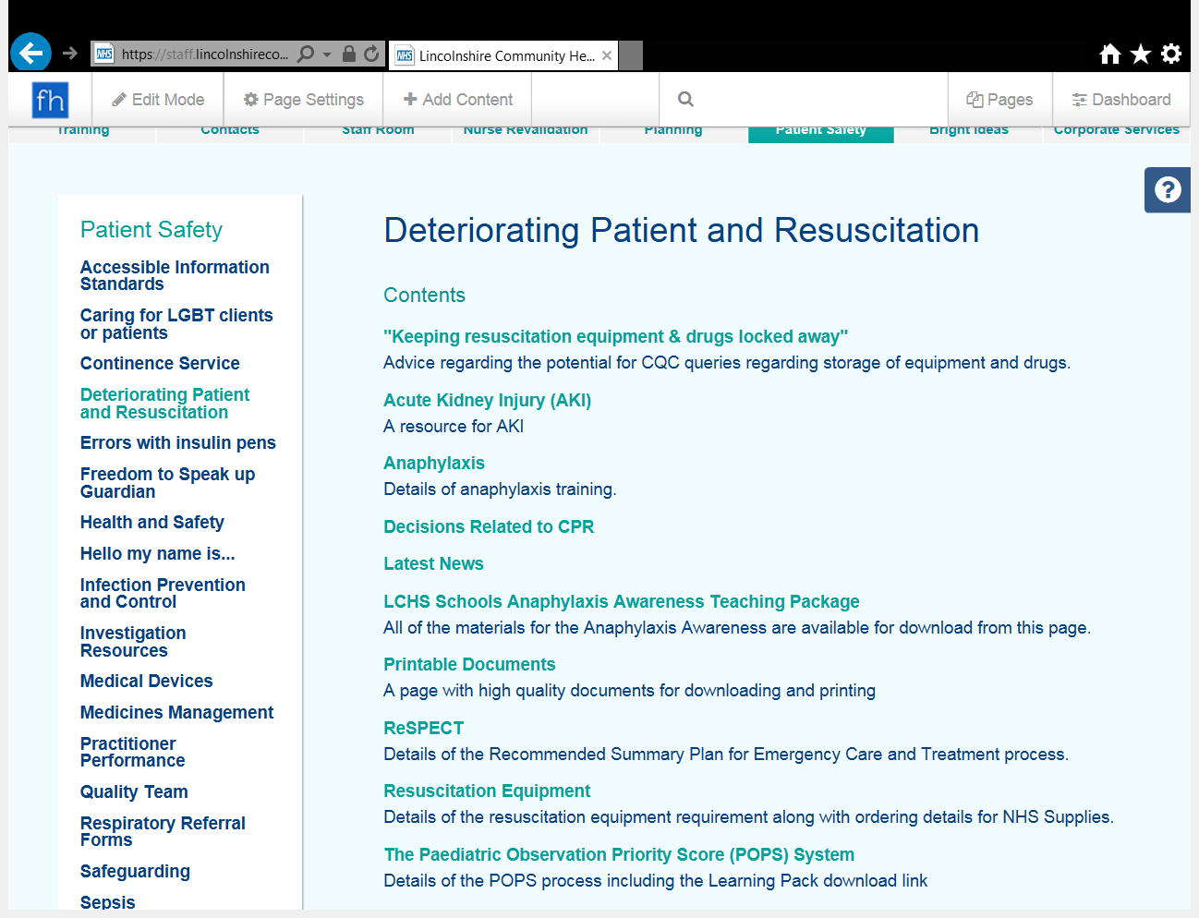

1. Click the link to register with eLearning for Health to complete the package

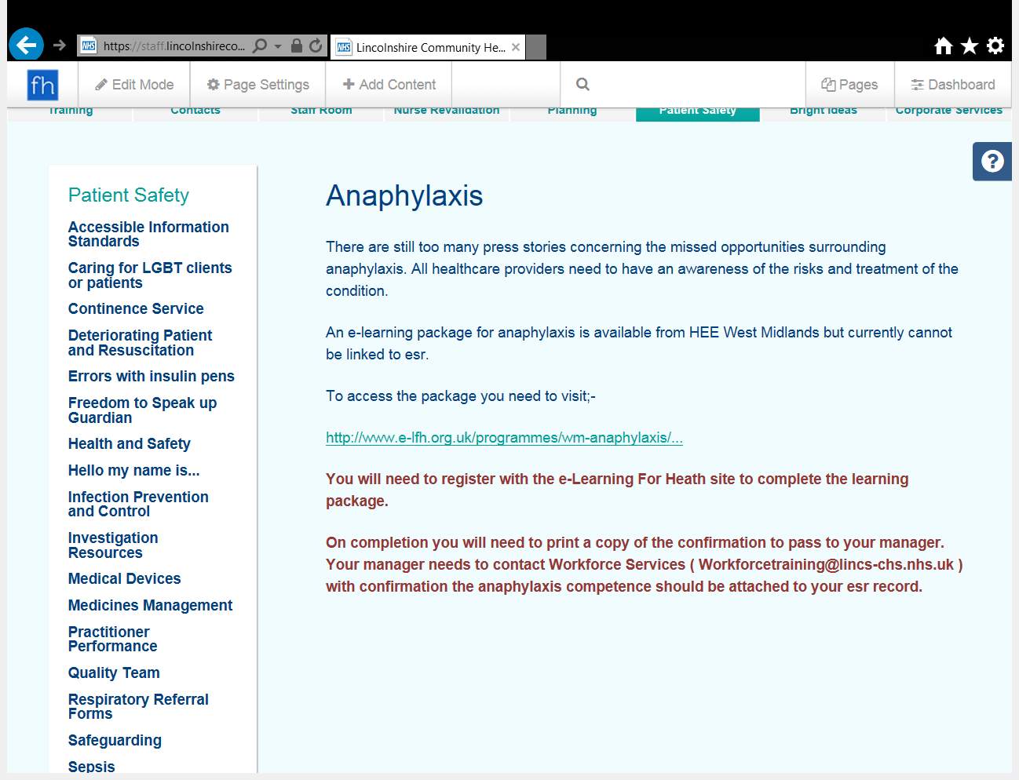

1. Record completion on ESR using the ‘External Training’ option on your learning record

For further help and support please contact the Training Admin Team at:

[workforcetraining@lincs-chs.nhs.uk](mailto:workforcetraining@lincs-chs.nhs.uk)

**LSCB eLearning – SELF NEGLECT for ALL Clinical Staff**

1. Open the link: https://www.lincolnshire.gov.uk/lscb/professionals/support/training/124632.article

2. Click Training

3. Register as a new user

4. Click Course Request

5. Select ‘Working with Adults Who Self-Neglect

6. On completion you will be given the option to save & print your certificate

7. Record completion using ‘External Training’ on your ESR learning record

**Parkinson’s Disease Awareness training**

www.parkinsons.org.uk/prtofessionals/resources /get-it-

time-medicine-management-patients-parkinsons-film.

Watch this film and complete the work sheet and return it to your manager

**Multiple Sclerosis [MS] awareness**

All clinical staff are required to undertake some brief MS ELearning.

Your manager will be able to give you the details.





**Patient Group Directions on ESR**

Enter ESR click on 818Elearning user

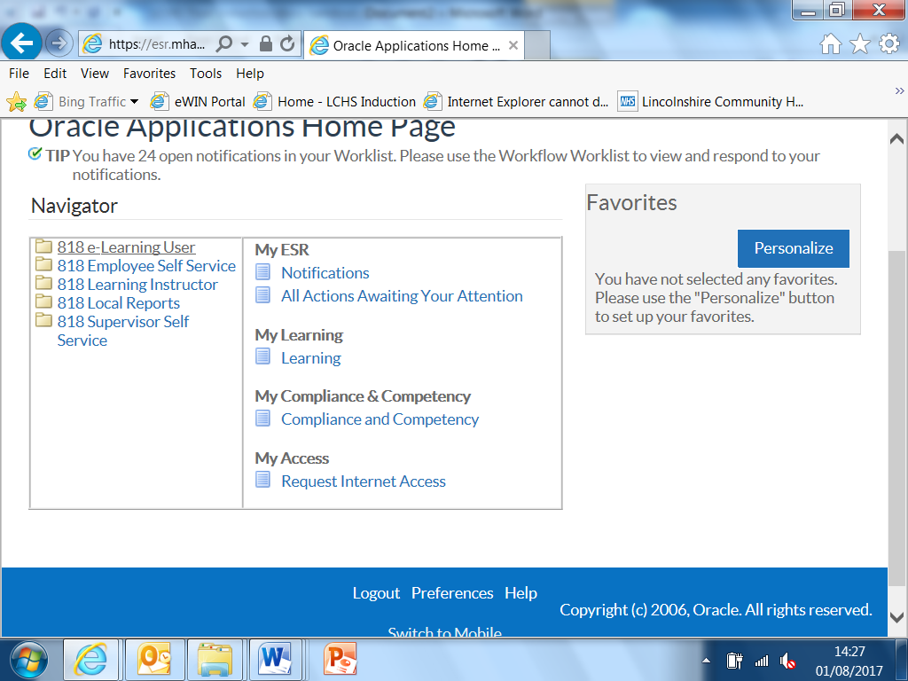

2. enter into the serach box Patient Group and click go

3. click on the link

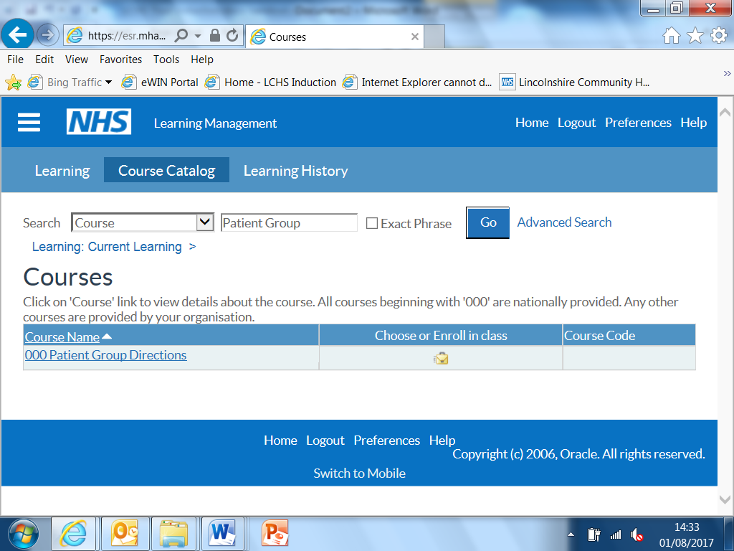

4. click again on 000 Pateient Group Directives

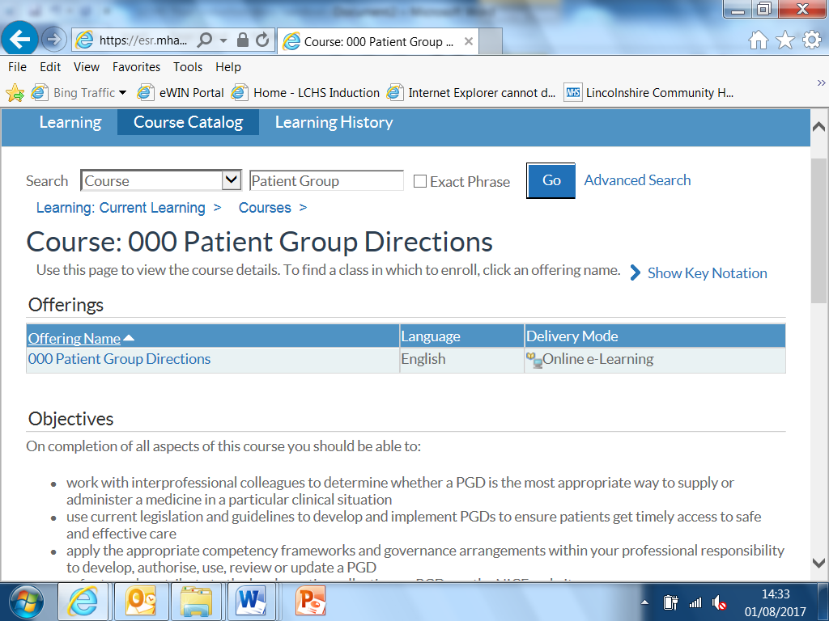

5. click on patient group directives

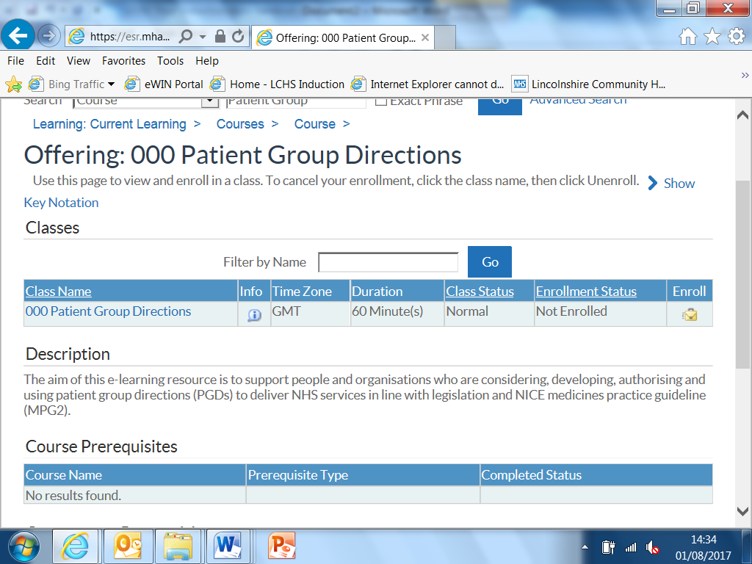

6. click on apply

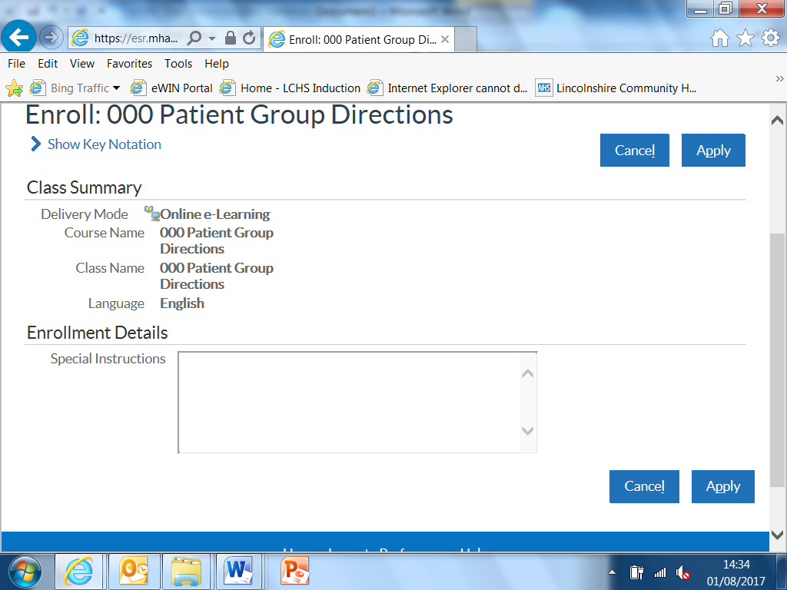

1. return to Elearning and press play

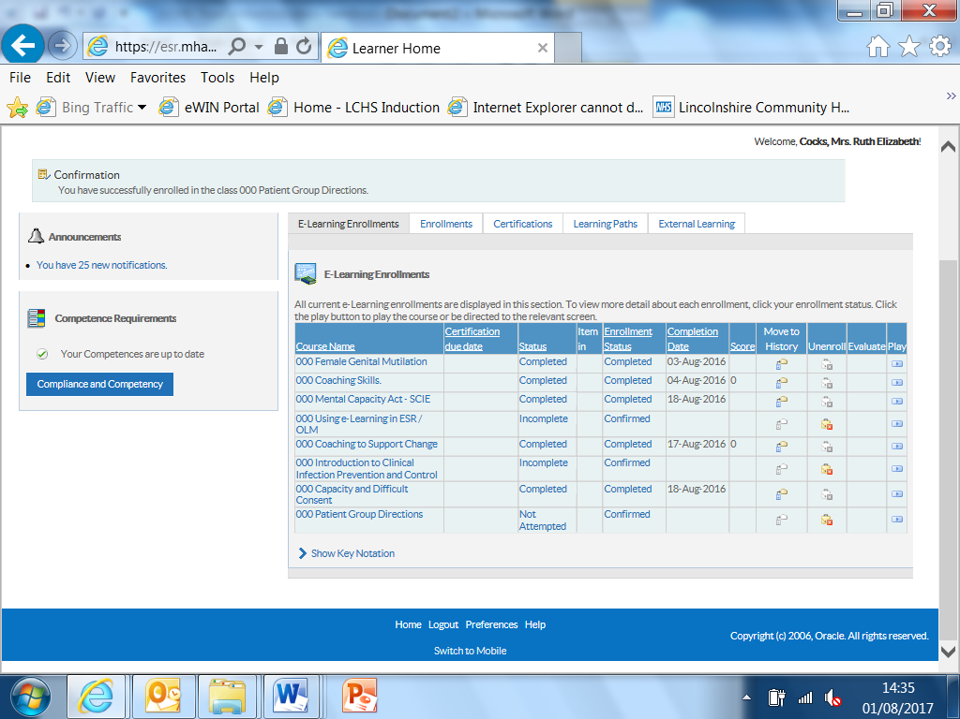

**Completion will be recorded on you Electronic staff record automatically**

**Useful contacts**

**IT issues**

**Phone: ICT Service Desk 0300 123 1020 Email: ITServiceDesk@ardengemcsu.nhs.uk**

**Monday to Thursday 8.30am to 5.30pm Friday 08.30am to 5.00pm**

**ICT Out of Hours Support: 5.30pm - 08.30am Mon - Thurs, from 5.00pm Friday and all Weekend including Public Holidays.**

**Occupational Health Service** 9am – 5pm Monday – Friday

Lincoln Tel: 01522 573597 Fax: 01522 579917

Or Boston Tel: 01205 445315 Fax: 01205 359925

Or Grantham Tel: 01476 464228 Fax: 01476 464688

**For Sharps injuries outside of these hours go to A&E**

**LCHS intranet**

The LCHS intranet is the site for current information guidance links and information, this is the site to refer to for up to date information.

Take a few minutes once you are registered to explore the areas. The text boxes show some of the information in each section and will help you know where to visit.

**Staff Room**

HR information

Staff room

Staff networks

Work style

Staff side

**Clinical supervision recording link**

**Links and contacts**

Includes policies

Expenses links

Bank staff

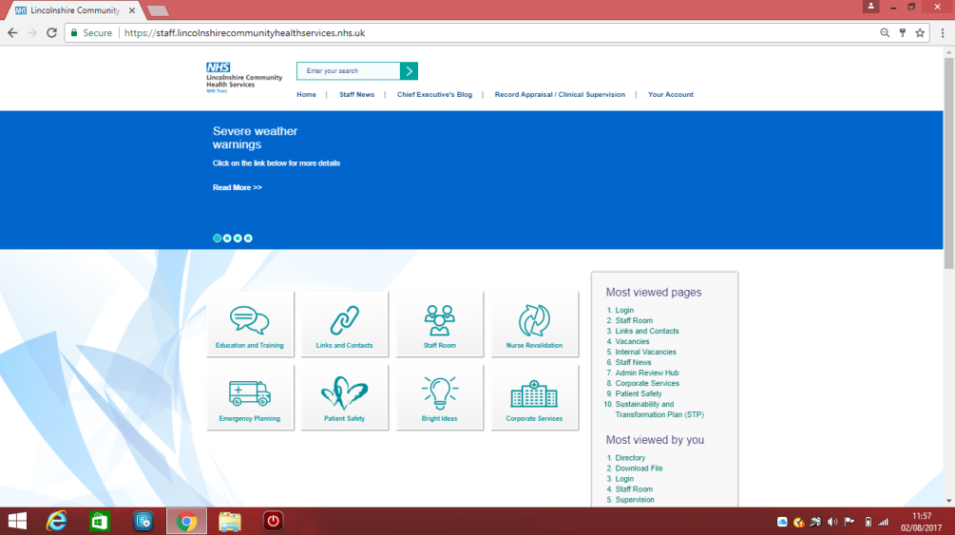

**Education and Training**

Click on the link Education and training hub

Useful short cuts

**Corporate Services**

Estates

Finance

Complaints and PALS

IM and T

**Patient Safety**

Safeguarding Medical Devices IPC

Health and Safety Medicines Management

Sepsis Pathway’s Urgent care

Resuscitation and deteriorating patients



***Medical Devices***

***Information for clinicians***

**What Is a Medical Device?**

A “medical device” is, any instrument, apparatus, appliance, material or health care product, excluding drugs, used for, or by, a patient or service user for: -

* Diagnosis, prevention, monitoring, treatment or alleviation of disease.
* Diagnosis, monitoring, treatment, or alleviation of, or compensation for, an injury or impairment.
* Investigation, replacement, or modification of the anatomy or of a physiological process.
* Control of conception.

**Life Cycle of Equipment**

The life cycle of equipment refers to a method of managing equipment that takes into account every part of the life of the item. This extends from before purchase until after disposal. Please refer to the Medical Devices Policy and the How to Guides for more detail on how to effectively manage those devices that you use. The documents may be accessed via the Trust Staff Intranet pages. You are strongly encouraged to read these.

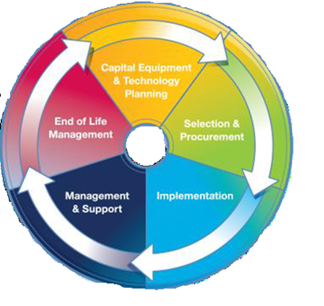

**Keeping Records**

Records management is an extremely important part of medical device management.

Each asset register holder needs to maintain an up to date and accurate list of all devices both in use and out of service.

Where a device has been loaned to a patient records must be maintained detailing patient demographics, any training provided to the patient, the date of loan and date that the device must be recalled for servicing etc.

Where devices are re-used the service must establish sufficient and appropriate decontamination methods and record keeping for the device.

2017/18 Mandatory and Induction Training handout/ Medical Devices



**Training**

Before you use a piece of equipment it is essential that you have received adequate training and are deemed competent on its use. Please ask your line manager about your local training processes.

If you provide equipment for your patients to use it is vital that the patient or carer receives training and a copy of the user manual for that device AND that you are satisfied that the user has sufficient knowledge to operate the device safely.

**Reporting Incidents**

The Datix system may be used to report incidents involving medical devices however in some instances where the harm is serious or a catastrophic failure of the device occurs the MHRA also need to be involved. If you are unsure or need advice please refer to the Medical Devices How to Guide for Adverse incidents or contact a member of the Medical Devices Team or one of the Trusts Risk managers for advice.

**To re-use or not to re-use?**

****Single-use is the term used to describe any medical device intended to be used on an individual patient during a single procedure and then discarded. It is best practice and LCHS policy that a device designated as single-use must not be re-used. A single-use device is also not intended to be reprocessed and used again, even on the same patient.

*‘Do Not Re-use’ symbol:*

*The synonyms for this symbol are* ***“single use”*** *or* ***“use only once”***

**Need more help?**

**Meet the Medical Devices Team**

We are happy to provide you with expert advice and guidance

|  |  |  |
| --- | --- | --- |
| **Cheryl Day** |  | **Mo Bird** |
| Head of  Medical Devices and Technology |  | Medical Devices Officer |
| Rm 131 Trentside  John Coupland Hospital |  | Grace Swan Health Clinic  Spilsby |
| Mobile 078 2723 4385 |  | Mobile: 078 1131 5210 |
| [Cheryl.day@lincs-chs.nhs.uk](mailto:Cheryl.day@lincs-chs.nhs.uk) or  [Cheryl.day@nhs.net](mailto:Cheryl.day@nhs.net) |  | [Maureen.bird@lincs-chs.nhs.uk](mailto:Maureen.bird@lincs-chs.nhs.uk) |

2017/18 Mandatory and Induction Training handout/ Medical Devices

Risk Assessment

|  |  |  |  |  |  |
| --- | --- | --- | --- | --- | --- |
| **Area/Location assessed**: |  | **Name of Assessor:** |  | **Date:** |  |

| **Hazard** | **Likelihood** | **Impact** | **Risk Score** | **Person at Risk and How They May Be Harmed** | **Existing Controls in Place** | **Additional controls required to eliminate risk or reduce as far as practicable** | **Residual Risk Rating** |
| --- | --- | --- | --- | --- | --- | --- | --- |
|  |  |  |  |  |  |  |  |
|  |  |  |  |  |  |  |  |
|  |  |  |  |  |  |  |  |

|  |  |  |  |  |
| --- | --- | --- | --- | --- |
| **Name:** |  | **Signature:** | **Review Date** |  |

Risk Assessment

**Manual Handling Operations Regulations 1992 (L23)**

|  |  |  |
| --- | --- | --- |
| ***Activity 1:- Label the Zones*** | | ***Activity 2:- M&H Risk Assessment*** |
|  | **Key**   * **G = Good** * **F = Fair** * **P = Poor** * **VP = Very Poor** | **The Regulations require employers to consider M&H:**  **A _ _ _ _**  **A _ _ _ _**  **R _ _ _ _ _**  **To complete a risk assessment:-**  **R _ _ _ _ _**  **M_ _ _ _ _**  **Employees should assess personal risk:-**  **T _ _ _**  **I _ _ _ _ _ _ _ _ _ _ _ _ _ _ _ _ _ _ _**  **L _ _ _**  **E _ _ _ _ _ _ _ _ _ _**  **O _ _ _ _ _ _ _ _ _ _ _** |

*Intentionally blank*

******Appendix A New employee checklist**

**STAFF IN CONFIDENCE**

**NEW EMPLOYEES CHECKLIST**

**Name**…………………………………………………………………………………

**Post**…………………………………………………………………………………

**Band**…………………………………………………………………………………

**Workbase** ………………………………………………………………………

**Date Commenced** .……………………………………………………………..

To be completed by Line Manger/Supervisor with New Employee on first day of duty and action points to be documented.

|  |  |  |  |
| --- | --- | --- | --- |
| **A** | **ITEMS TO BE DISCUSSED (Where Applicable)** | **Tick as applicable** | **Agreed Actions Required**  **Target Dates**  **Comments** |
| 1. | Notification of change of personal circumstances (EF2) eg. Name, marital status, civil partnership status, next of kin, address, telephone number etc. |  |  |
| 2. | Uniforms, Protective Clothing/Protective Equipment |  |  |
| 3. | Keys / Security Access Codes |  |  |
| 4. | Bleep/Radio Pager/Mobile Phone/Lap Top |  |  |
| 5. | Other items – please specify |  |  |

|  |  |  |  |
| --- | --- | --- | --- |
| **B** | **INTRODUCTIONS & EXPLANATIONS** | **Tick as applicable** | **Agreed Actions Required**  **Target Dates**  **Comments** |
| 1. | Introductions to immediate work colleagues and working environment (include site plan if available) |  |  |
| 2. | Explanation of fire regulations e.g., Evacuation procedures, raising alarm, location of fire exits, appliances etc. |  |  |
| 3. | Explanation of security arrangements, e.g., Building security, personal safety, security of personal belongings and loss/theft procedure. |  |  |
| 4. | Staff Facilities: - Toilet   * Rest & Refreshments * Coat/Lockers * First Aid – Nominated Person * Parking |  |  |
| 5. | Location of public telephones & postal arrangements, notice boards & rules regarding use of NHS telephones. |  |  |
| 6. | Working hours and arrangements including flexi time |  |  |
| 7. | Confidentiality of information, re Patients, Staff and Organisation Business |  |  |
| 8. | Introduction to website, Shared Knowledge & Information (SKI) (ski.lincolnshire.nhs.uk/LCHS/forms/alltems.aspx) and Freedom of Information Publication Scheme – (expectation that individual responsible officers’ names will be published and available to members of the public as part of the publication scheme). |  |  |

|  |  |  |  |
| --- | --- | --- | --- |
| **C** | **EXPLANATION OF CONDITIONS POLICIES/PROCEDURES** | **Tick as applicable** | **Agreed Actions Required**  **Target Dates**  **Comments** |
| 1. | Check job description has been issued and fully explained. |  |  |
| 2. | Overtime, on-call, stand-by arrangements, time owing (if applicable) |  |  |
| 3. | Explanation of your Performance Matters discussed and 6 month appraisal meeting scheduled. (see footnote on page 7) |  |  |
| 4. | Explanation of local Workforce Development Policy, on-line Training Directory and process for accessing learning and development, including completion of T1’s for external training conferences. |  |  |
| 5. | Annual Leave – entitlement, when and how to take it and issue Annual Leave Record Card  Bank and Statutory Holidays |  |  |
| 6. | Sickness reporting and certification requirements  Absence, punctuality and attendance |  |  |
| 7. | Health and Well-being  Improving Working Lives – talk through the organisation’s approach to valuing staff, balancing work and home life ethos and flexible working policies. |  |  |
| 8. | NHS / Organisation General Conditions of Employment  - contractual obligations |  |  |

|  |  |  |  |
| --- | --- | --- | --- |
| 9. | Pay – Completion of time sheets if appropriate  Method of payment e.g., how, where and when  Pay enquiries  Pension arrangements & Handbook |  |  |
| 10. | Consent for undertaking additional paid employment |  |  |
| 11. | Standard of appearance and behaviour expected towards patients/clients/members of the public |  |  |
| 12. | Explanation of relevant financial processes including:   * provision of procedure notes * completion of Authorised Signatory Form * standing Orders and Financial Instructions |  |  |

|  |  |  |  |
| --- | --- | --- | --- |
| **D** | **STAFF FACILITIES/BENEFITS** | **Tick as applicable** | **Agreed Actions Required**  **Target Dates**  **Comments** |
| 1. | Trade Unions/Professional Staff Associations, Membership & Consultative/Bargaining machinery in the Organisation |  |  |
| 2. | Personal/Work Problems  Manager, Occupational Health, Staff Counselling Service, Human Resource Department |  |  |
| 3. | Childcare and Carer Coordination Service.  For further information visit http://ski.lincolnshire.nhs.uk/LCHS/forms/alltems.aspx |  |  |

|  |  |  |  |
| --- | --- | --- | --- |
| **E** | **RECORDS MANAGEMENT STANDARDS** | **Tick as applicable** | **Agreed Actions Required**  **Target Dates**  **Comments** |
| 1. | Awareness of Records Management Policy |  |  |
| 2. | Detail of the type of records kept within the work area. What is a record? Not just manual files. |  |  |
| 3. | Advice on matters of information security and confidentiality |  |  |
| 4. | Advice on how records should be completed – black ink, legible, factual, abbreviations etc |  |  |
| 5. | Advice on who is able to enter information into a record |  |  |
| 6. | Implications of Data Protection Act 1998 and Freedom of Information Act 2000 |  |  |
| 7. | Signature record completed for clinical record keeping |  |  |
| 8. | Advice on the storage of records |  |  |
| 9. | Archiving and destruction of records |  |  |
| 10. | Creating a new record – check to see if other records already exist |  |  |
| 11. | Professional codes of conduct for records management |  |  |

SIGNATURE OF EMPLOYEE………….……………………………………………………………..…......

DATE ………………………………………………………………….………………………………...………

SIGNATURE MANAGER/SUPERVISOR……………………………………………………………..…….

POST HELD ……………………………………………………………………………………………..…..…

DATE ……………………………………………………………………………………..…………...…..……

**Completed Checklist signed copy to Personal file, copy for individual staff member**

**Undertake Hand Hygiene Assessment**