

Essential Mandatory Training

Staff Guide

2018/19

**Contents**

Section 1 Overview of Core Skills Training Framework

* Essential Mandatory Training Competencies

Section 2 Education & Workforce Development Team

* Team Objective
* Meet The Team

Section 3 Annual Core Essential Mandatory Training

* Skills for Health UK Core Skills Training Framework (CSTF)
* About Skills for Health
* EastMidlands Streamlining Project
* Core Subjects
* Additional Requirements

Scetion 4 Annual Refresher Training Programmes

* Clinical Staff
* Non-Clinical Staff

Section 5 Freedom to Speak Up Guardian

Section 6 Equality, Diversity & Human Rights

Section 7 Conflict Resolution

* Lone Working/ Managing Violence & Aggression

Section 8 Health, Safety & Wellbeing

Section 9 Fire Safety

Section 10 Basic Life Support

Section 11 Infection Prevention & Control

Section 12 Information Governance

Section 13 Safeguarding Vulnerable People

Section 14 Clinical Supervision

Section 15 Medical Devices

Section 16 Other Useful Resources

**Section 1**

**Overview of Core Skills Training Framework - Essential Mandatory Training Competencies**

|  |  |  |  |  |  |  |
| --- | --- | --- | --- | --- | --- | --- |
| **Subject** | **Level** | **CSTF Code** | **Staff Group** | **Refresher Period** | **Delivery** | **Delivery** |
| **Infection Prevention & Control** | **Level 1** | IPC01 | All Staff | Annual | Induction Day 1 | Mandatory Training Day 1 |
| **Infection Prevention & Control** | **Level 2** | IPC02 | All Staff | Annual | Induction Day 1 | Mandatory Training Day 1 |
| **Safeguarding Adults & Children** | **Level 1** | SA01, SC01 | All Staff | Annual | Induction Day 1 | Mandatory Training Day 2 |
| **Safeguarding Adults & Children** | **Level 2** | SA02, SA02 | Clinical Staff | Annual | Induction Day 4 | Mandatory Training Day 2 |
| **Safeguarding Children** | **Level 3** | SC03 | Clinical Staff | Annual |  | Mandatory Training Day 2 |
| **Safeguarding Adults** | **Level 3** | Local 818 | Clinical Staff | Annual |  | Mandatory Training Day 2 |
| **PREVENT WRAP** | **n/a** | Included in SA02 | All Staff | Annual | Induction day 2 | Mandatory Training day 2 |
| **Moving and Handling** | **Level 1** | MH01 | All Staff | Annual | Induction Day 1 | Mandatory Training Day 1 |
| **Moving and Handling** | **Level 2** | MH02 | Clinical Staff | 2 Yearly | Induction Day 5 | Clinical Pathway |
| **Resuscitation (Adults & Children)** | **Level 1** | RE01 | All Staff | Annual | Induction Day 1 | Mandatory Training Day 1 |
| **Resuscitation (Adults & Children)** | **Level 2** | RE02 | All Staff | Annual | Induction Day 1 | Mandatory Training Day 1 |
| **Resuscitation (Adults) ILS** | **Level 3** | RE03 | Clinical | Annual |  | Clinical Pathway |
| **Resuscitation (Children) PILs** | **Level 3** | RE03 | Clinical | Annual |  | Clinical Pathway |
| **Anaphylaxis** | **n/a** | n/a | Clinical | Annual | eLearning | eLearning |
| **Information Governance** | **n/a** | IG01 | All Staff | Annual | Induction day 1 | Mandatory Training Day 1 |
| **Equality, Diversity & Human Rights** | **n/a** | EDHR01 | All Staff | Annual | Induction Day 1 | Mandatory Training Day 1 |
| **Conflict Resolution** | **n/a** | CR01 | All Staff | Annual | Induction Day 2 | Mandatory Training Day 1 |
| **Health, Safety & Wellbeing** | **n/a** | HSW01 | All Staff | Annual | Induction Day 1 | Mandatory Training Day 1 |
| **Fire Safety** | **n/a** | FS01 | All Staff | Annual | Induction Day 1 | Mandatory Training Day 1 |

**Local Competencies:**

Anaphylaxis Awareness – Clinical Staff

Safeguarding Adults Level 3 & 4

Safeguarding Children Level 4

**Section 2**

**Education & Workforce Development Team**

**Our Team Objective:**



As part of the Workforce and Transformation Directorate, the Learning & Development Service aims to **S**upport, **E**ngage, **E**ducate, **D**evelop staff to **S**uceed and be a progressive and continuously improving workforce and deliver the best possible safe patient experience within Lincolnshire Community Healthcare Services NHS Trust

**Meet The Team:**

Head of Service Suzanne Bradley

Learning & Development Manager Emma Lee

Professional Development Manager Valerie Ronis

Apprentice Centre Lead Lee Gifford

Training Delivery Lead Ruth Cocks

Trainer Shaun Farrell

Trainer Alex Aldous

Facilitator Yvonne Swaine

Business Support Lead Angela Bradley

Apprentice Centre Administrator Abbie Clayson

Business Support Administrator Kayleigh Taylor

Learning & Development Apprentice Grace Thompson

**Section 3**

**Annual Core Essential Mandatory Training**

**Skills for Health UK Core Skills Training Framework (CSTF)**

**About Skills for Health**

Skills for Health is the Sector Skills Council for Health. It helps the whole UK health sector develop a more skilled and flexible workforce. Skills for Health are responsible for defining the Core Skills Training Framework which has been implemented across NHS Trusts in the East Midlands.

**East Midlands Streamlining Project**

The regional group was set up in October 2014 to working together to identify and share best practice to:

* To agree the implementation of an identified Training Framework regionally
* To agree a library of e-learning packages/subjects that can be shared regionally
* To increase the overall compliance rates for completion of statutory and mandatory training
* To reduce the overall time taken to complete statutory and mandatory training for all staff groups

LCHS is fully aligned to the Core Skills Training Framework and the Corporate Induction and Annual Mandatory refresher programmes include the 9 core subjects.

The 9 core subjects as defined by the Skills for Health framework are:

1. Conflict Resolution
2. Equality, Diversity & Human Rights
3. Fire Safety
4. Health, Safety & Welfare
5. Infection prevention & Control
6. Information Governance (England)
7. Moving & Handling Level 1 & 2
8. Resuscitation – Level 1, 2 (BLS) and Level 3 (ILS, pILS)
9. Safeguarding Adults & Children level 1,2 & 3 including PREVENT

This guide supports face to face delivery.

**Section 4**

**Clinical Mandatory Programme 2018/19**

09:45 Director’s Welcome

Fire safety

Health and safety and Wellbeing

11:00 BREAK

11:15 Emergency Planning

Equality and Diversity

Conflict Resolution

Customer Care

Moving & Handling Level 1

13:00 LUNCH

13:30 Medicines Management

Infection Prevention & Control

Break

Basic Life Support teaching & practical assessments

Information Governance

16.10 Questions & Close of Core Day

16.16-17.15 Mentor Update for Nurse Mentors

**Additional Role Specific Requirements:**

Immediate Life Support (ILS)

Paediatric Immediate Life Support (pILS)

Moving & Handling Level 2

Safeguarding Levels 1, 2 & 3 inc PREVENT – service specific classe



**Non - Clinical Mandatory Programme 2018/19**

09:45 Director’s Welcome

Fire safety

Health and safety and Wellbeing

11:00 BREAK

11:15 Safeguarding Vulnerable People Level1 I

Infection Prevention & Control

13:00 LUNCH

13:30 Emergency Planning

Equality and Diversity

Conflict Resolution

Customer Care

Moving & Handling Level 1

Break

Basic Life Support teaching & practical assessments

Information Governance

16.15 Questions & Close

**Section 5**

**Freedom to Speak Up Guardian:**

Gemma Cross

Named Nurse, Safeguarding Team

07818 421518

[Gemma.cross@lincs-chs.nhs.uk](mailto:Gemma.cross@lincs-chs.nhs.uk)

Gainsborough Health Centre

Hickman Street

Gainsborough

Freedom to speak up guardians work with trust leadership teams to create a culture where staff are able to speak up in order to protect patient safety and empower workers.

The role of the freedom to speak up guardian has been created as a result of recommendations from Sir Robert Francis' “Freedom to Speak Up” review, published in February 2015.

Gemma Cross has worked for LCHS for two years as a deputy named nurse within the corporate safeguarding team and is passionate about patient safety. Gemma will be working with the trust leadership teams to support the organisation to become a more open and transparent place to work, where all staff are actively encouraged and enabled to speak up safely.

 

**Whistle Blowing:**

The Public Interest Disclosure Act 1998 amended the Employment Rights Act 1996 to give protection from victimisation and make it unlawful to dismiss individuals who have made a "protected disclosure" in the public interest. The Act sets out a simple framework to promote responsible whistle-blowing.Whistle-blowing may be described as a process of reporting matters of malpractice regarding patient/service user care, service provision, use of resources or environmental issues that have not/are not being dealt with adequately by other processes.

Any employee at one time or another may have concerns about what is happening at work. Usually these concerns are easily resolved.  However, when they are about unlawful conduct, financial malpractice, fraud and corruption, or concerns about the quality of patient care, it can be difficult to know what to do.This policy enables employees to raise concerns about such malpractice at an early stage and in the right way.  The organisation would rather that employees raised any matter when it is just a concern than wait for proof.  This would be in the best interests of patients and carers in the longer term.  This includes not only employees but also contractors providing services, agency workers and trainees on vocational and work experience schemes.

**Section 6**

**Equality, Diversity & Human Rights:**

Lincolnshire Community Health Services NHS Trust will use equality legislation as a lever to enable our trust to achieve two key things:

* firstly to deliver patient-centered services that are accessible to everyone;
* and secondly to become a model employer that attracts and retains the best employees who reflect the population that we serve.

This ED&HR policy applies to all staff working within the Trust, (including temporary staff, contractors, students and those with honorary contracts) and relates to other Trust staff, contractors and staff from other organisations working on Trust premises.

**Key Learning Points**

As part of our on-going commitment to promoting equality, valuing diversity and protecting human rights, Lincolnshire Community Health Services NHS Trust is committed to eliminating discrimination against any individual (individual means employees, patients, services users and carers) on the grounds of the nine protected characteristics defined by the Equality Act (2010) age, disability, gender, gender reassignment, sexual orientation, religion & belief, civil partnership/marriage, pregnancy/maternity and race.

**Definitions**

***Equal opportunities*** - emphasises the structures, systems and measures of groups within society

and within organisations. Equality of opportunity is about addressing representation and balance.

***Equality*** *-* is about creating a fairer society where everyone can participate and has the opportunity

to fulfil their potential. It is backed by legislation designed to address unfair discrimination based on

membership of a particular group.

***Diversity***- is about the recognition and valuing of difference in the broadest sense. It is about

creating a working culture and practices that recognise, respect, value and harness difference for

the benefit of the organisation and individuals.

***Direct discrimination***– is where a criterion is applied overtly, that results in less favourable

treatment of someone because of their ethnicity, gender, maternity, marriage or civil partnership,

disability, religion or belief, sexual orientation, or age e.g. “No Irish served here”.

***Indirect discrimination***– is where a group of people of the same race, ethnicity, gender, marital or

civil partnership status, disability, religion or belief, sexual orientation or age are unjustifiably at a

disadvantage in their ability to comply with a specific provision, criterion or practice e.g. a rule

saying all staff must be over five feet ten tall is likely to discriminate against women and some racial

groups even though it doesn’t specifically say no women

***Equality Delivery System (EDS2)***

The Equality Delivery System (EDS) for the NHS was made available in June 2011. It was

formally launched on 11 November 2011. Following an evaluation of the implementation of the

EDS in 2012, and subsequent consultation with a spread of the NHS organisations, a refreshed

EDS is now available. It is known as EDS2.

The main purpose of the EDS, was, and remains, to help local NHS organisations, in discussion

with local partners including local people, review and improve their performance for people with

characteristics protected by the Equality Act 2010. By using the EDS, NHS organisations can also

be helped to deliver on the public sector Equality Duty (PSED).

EDS is a tool to support the NHS to integrate equality and meet the requirements of the

Equality Act2010. The EDS was re-launched in November 13 and is now known as *EDS2.* It is more

streamlined and simpler to use compared with the original EDS. At the heart of the EDS2 there are

18 outcomes, grouped under 4 Goals, shown in the below table. These outcomes relate to issues

that matter to people who use, and work in, the NHS.

**Goal**

**1** Better Health Outcomes

**2** Improved patient access and experience

**3** A representative and supported workforce

**4** Inclusive Leadership

**Contact for further information:**

Rachel Higgins

Equality & Diversity & Patient Experience Lead

01522 308894

[Rachel.higgins@lincs-chs.nhs.uk](mailto:Rachel.higgins@lincs-chs.nhs.uk)

**Section 7**

**Conflict Resolution:**

**Lone Worker and Violence and Aggression at Work Policy**

Lincolnshire Community Health Services NHS Trust recognises that some staff may have the requirement to work by themselves for significant periods of time in the community without close or direct supervision, in isolated work areas and often out of normal working hours. The purpose of this policy is to protect staff, so far as is reasonably practicable, from the risks that are associated with lone working, violence and aggression.

**Resonable Force**

A person may use such force as is reasonable in the circumstances for the purposes of:

1. self-defence; or
2. defence of another; or
3. defence of property; or
4. prevention of crime; or lawful arrest.

In assessing the reasonableness of the force used, prosecutors should ask two questions:

was the use of force necessary in the circumstances, i.e. Was there a need for any force at all? and

was the force used reasonable in the circumstances?

**Contact for further information:**

Carl Kisby

Security and Resilience Manager

07580897894

[Carl.kisby@lincs-chs.nhs.uk](mailto:Carl.kisby@lincs-chs.nhs.uk)

**Section 8**

**Health, Safety & Wellfare:**

Lincolnshire Community Health Services NHS Trust recognises that successful management of health and safety has a direct and beneficial relationship for effective delivery of its core business services.

The Trust believes it is the responsibility of management to lead by example and encourage employees to actively participate in the development and maintenance of an open and transparent culture that accepts individual accountability for health, safety and wellbeing performance.

**Definitions**

**Hazard -** A hazard can be defined as anything with the potential to cause harm, loss or

suffering and can relate to all kinds of situations including clinical treatments and the

financial position as well as the traditional health and safety issues.

**Risk** - A risk is the likelihood that a hazard will cause a specified harm to someone or

something.

**Risk Register** - A risk register is part of the process of recording how we will manage

the risks within individual departments and organisation.

**Risk Assessment** – Risk assessment is nothing more than a careful examination of

what, in your work, could cause harm to people, so that you can weigh up whether you

have taken enough precautions or should do more to prevent harm.

**Risk Management** – Risk Management is the recognition and effective management of

all threats and challenges to the Trust's objectives and values.

**Health** and **Safety at Work** etc **Act 1974**. Often referred to as HASAW or HSW, this **Act** of Parliament is the main piece of UK **health** and **safety legislation**. It places a duty on all employers "to ensure, so far as is reasonably practicable, the **health**, **safety** and welfare at **work**" of all their employees

**Contact For Further Information:**

David Sedman

Health and Safety Advisor

01522 308686

[David.sedman@lincs-chs.nhs.uk](mailto:David.sedman@lincs-chs.nhs.uk)



Physio For You Clinics are continuing to be held. If you would like to book an appointment please contact:

Nav Amlani

Telephone: 01427 816540

Mobile: 07815 491963

Email: [navros.amlani@lincs-chs.nhs.uk](mailto:navros.amlani@lincs-chs.nhs.uk)

**Section 9**

**Fire Safety:**

Fire is a potential hazard in all hospitals and healthcare premises. The consequences of a fire in any LCHS properties or other premises the LCHS occupies, could be potentially serious since many of the patients and clients are dependent on staff.

All employees within the trust have an obligation to observe fire precautions at all times. It is imperative they understand what to do in the event of fire, to ensure the safety of patients, colleagues, visitors and themselves following local evacuation procedures.

Actions to take in the event of a fire:

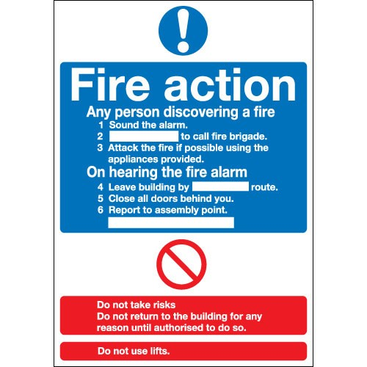 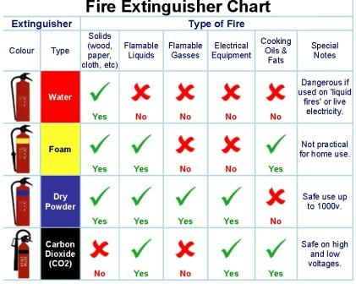

**Fire Extinguishers**

Fire extinguishers may be used to help fight smaller fires in the workplace or to protect evacuation routes in the event of a larger one.

**Contact For Further Information:**

David Sedman

Health and Safety Advisor

01522 308686

[David.sedman@lincs-chs.nhs.uk](mailto:David.sedman@lincs-chs.nhs.uk)

**Section 10**

**Basic Life Support:**

LCHS recognises that an effective response to, and the management of a cardiac arrest or medical emergency is a key objective.

**All staff members have a responsibility to:**

* Maintain competence in resuscitation techniques through participation in training in

accordance with the Resuscitation Training Matrix.

* Responding to cardiac arrest and medical emergencies in accordance with Resuscitation

and DNACPR policies.

* Report and take part in audit processes for cardiac arrests and medical emergencies in

accordance with LCHS policies and procedures

* Ensure they are aware of the location of, and have easy access to personal protective

equipment.

Mouth to mouth ventilation can no longer be supported. **Only until** appropriate personal protective

and airway management equipment (e.g. pocket mask, bag valve mask and supraglottic airway) is

available compression-only CPR with manoeuvres to maintain an airway should be carried out.

**Chest compressions with ventilations** is the minimum standard expected of a Health Care

provider.

Resuscitation Council (UK) recommends that standard principles of infection control and droplet

precautions are the main control strategies to be used in the resuscitation of patients and should be

followed rigorously.

**Contact For Further Information:**

Tim Balderstone

Deteriorating Patient & Resuscitation Training Officer

07833237236

[tim.balderstone@lincs-chs.nhs.uk](mailto:tim.balderstone@lincs-chs.nhs.uk)



Resuscitation Council (Oct 2015) Resuscitation Guidelines

<https://www.resus.org.uk/resuscitation-guidelines/>

**Further Role Specific Training Required:**

|  |  |  |  |
| --- | --- | --- | --- |
| **Level** | **Staff Group** | **Refreshment Training** | **Update Period** |
| **RE03**  **Adults**  **RCUK**  **ILS** | The following clinical staff will require Immediate Life Support Training.  **Cardiac Rehabilitation**  Band 5– 7  **Ward based staff**  Band 5 – 7  **Minor Injury and Illness Units and Access Centre**  Band 5 – 7  LCHS employed Drs  **Gainsborough Surgical Day Centre**  Band 5 – 7  **Louth and Skegness Unscheduled Care Centres**  Band 5 - 7  LCHS Employed Dr’s  **Out of Hours**  Bands 5 – 7  **Rapid Response**  Bands 5 – 7  **Podiatrists**  Band 5 – 8  **Sexual Health** *(Staff who fit or support IUD fitting only – named individuals)*  Bands 5 – 8  LCHS employed Drs. | Annual half day  re-certification | Annually |
| **RE03**  **Children**  **RCUK**  **PILS** | The following clinical staff will require Paediatric Immediate Life Support Training.  **MIU & WIC**  Band 6 – 7  LCHS employed Drs  **Louth and Skegness Unscheduled Care Centre**  Band 6 – 7  LCHS employed Drs  **Out of Hours**  Bands 6 – 7 | Annual half day  re-certification | Annually |

The link for the anaphylaxis eLearning is available on the Staff Intranet under Patient Safety as below:

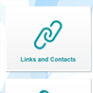 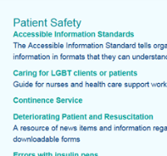 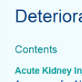

**Section 11**

**Infection Prevention & Control:**

**Infection prevention and control is everyone’s business**

Your compliance with simple but effective infection prevention and control measures is vital to protect your patients, your colleagues, your family and YOU from health care associated infection.

**Lincolnshire Community Health Services NHS Trust Commitment:**

Zero tolerance to avoidable healthcare associated infection. We take every step to reduce the risk of avoidable infections through staff education, robust audit, implementation of policies and guidelines and learning lessons from experiences.

The Infection Prevention and Control Team (IPCT) is avialble to advise and promote a safe environment for staff, patients and visitors and to ensure that the risks of Health Care Associated Infections (HCAIs) are kept to the absolute minimum.

**The Chain of Infection**

The transmission of infection depends on six elements which link together like a chain. The elements are infectious agent, a reservoir for its growth, a portal of exit into the host, and a susceptible host

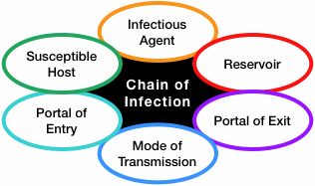

**Standard Precautions**

Blood and other body fluids can contain blood borne viruses or other pathogenic bacteria which could present a risk of infection. It is not always possible to know who is infected so the following precautions must be taken.

Standard Infection Prevention and Control precautions are measures which must be used with ALL patients/clients at ALL times.

* Hand washing and use of alcohol hand rub and skin care
* Personal Protective Equipment (PPE)
* Sharps & Waste handling and disposal
* Linen handling and disposal
* First Aid & Inoculation injuries
* Management of Spillages (blood / body fluids)
* Decontamination
* Environmental Cleanliness

**Hand Hygiene**

The single most effective way of reducing the spread of infection by removing transient bacteria.

|  |  |  |
| --- | --- | --- |
| **Liquid Detergent Soap** | **Alcohol Rub** | **Hand Cream** |
| Before and after duty.  After using the toilet.  Before handling food.  When visibly contaminated. | In between patient contact (where hands are not soiled).  Before, during and after aseptic procedures. | After increased frequency of washing.  Before breaks.  At the end of a shift |

**Waste Management Regualtions 2005**

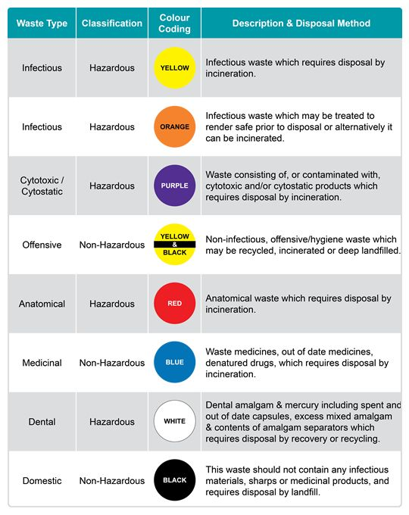

**Contact for Further Information:**

Lynne Roberts

Lead Matron for Infection Prevention & Control

[Lynne.Roberts@lincs-chs.nhs.uk](mailto:Lynne.Roberts@lincs-chs.nhs.uk)

Tel: 01775 652276

Mobile : 07769 242741

**Section 12**

**Information Governance:**

Information Governance ensures necessary safeguards for, and appropriate use of, patient and personal information. Through a well-defined Information Governance Management Framework (IGMF) ensures that personal information is handled with appropriate Confidentiality, Security and is compliant with information laws.

**8 DATA PROTECTION PRINCIPLES**

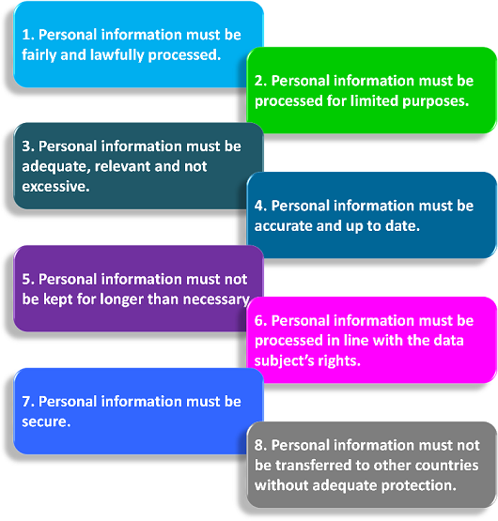

**Top Tips:**

* Housekeep your PC as we are all better at saving than deleting files.

*Electronic clutter is just as bad as paper.*

* Follow the E-mail Policy and Procedure as e-mail carries the same legal weight as a letter in a Court of Law.
* Limit the use of faxes where possible due to the inherent risk of them being sent to a wrong recipient. Follow Safe Haven Process.
* Use a network drive such as H (Home) or J (Network) to
* save important documents. If saved on the C Drive (Hard Drive) and it fails, you will lose everything.

**Clear Desk Policy**

Any confidential information must be placed out of sight, in locked cabinets when not in use. This includes any portable laptop comput- ers, USB, Portable Drive, Camera etc., that may contain confidential information.

**Safeguard portable laptop computers when travelling and when using**

**Clear Screen Policy**

Workstations will require a username and password to be entered before accessing any information. Remember when you leave your computer to press ‘Ctrl’ + ‘Alt’ + ‘Delete’ and lock your computer, so that it cannot be accessed by anyone who is unauthorised. Your computer can only be accessed by using your password and you must not share your password.

**Shredding Policy**

All confidential waste should be placed in the allocated “Shred-it” consoles where this applies or shredded confidential waste can go out with normal recycling provided it has been shredded using a Cross-Cut Shredder. Non-confidential waste can be placed in the cardboard recycle bins. Shredding equipment within departments must comply with Trust standards which is a Cross-Cut or Confetti-Cut Shredder .

**What is the Registration Authority?**

The Registration Authority is provided by NHS Arden & GEM CSU on behalf of the Trust to supply smartcard access and ID card provision.

**How do I report the loss of a smartcard / ID?**

1. Inform your Line Manager
2. Complete the online reporting form

**What is a Subject Access Request (SAR)?**

The Data Protection Act 1998 states that all living individuals have a right to access any information that an organisation may hold about them.

**How long do I have to respond to an access to records request?**

The Trust should endeavour to respond to all requests within **21 working days**

(but no later than 40 days) from receipt of all information (ID Check)

and fee.

**What should I do if I receive an access to records request?**

Please forward requests to;

Access to Information Team Unit 14, The Point

Lions Way, Sleaford. NG34 8GG

E-mail securely: [**LHNT.Subject-Access-Requests@nhs.net**](mailto:LHNT.Subject-Access-Requests@nhs.net)

Telephone: 01522 308974

**What is an Freedom of Information (FOI) Request?**

**What is the Freedom of Information Act?**

This Act gives the public a right of access to any files or information held by the Trust. There are some exemptions, but the general rule is that we have to provide the information unless we can show that there is a good, public interest, reason not to.

**Who can apply for information under the Act?**

Anybody can make a request under the Act – this includes commercial companies, journalists, patients and the public.

**What information does the Act cover?**

It applies to any information held by the Trust, in any form -electronic as well as paper records. E-mails have to be treated in the same way.

**How is an FOI request made?**

Requests have to be made in writing – an e-mail counts as a written re- quest. The Trust has a maximum of 20 working days to confirm whether or not we have the information requested and to provide it.

**What should I do if I receive a request?**

Send it immediately to the FOI Lead, who deals with FOI requests. It’s important that you do this immediately because the clock starts ticking on the **20th working day** the minute the request is received in the Trust.

Post: Freedom of Information Team Engagement, Communications and Marketing

NHS Arden & GEM CSU, Scarsdale Room 19,

Nightingale Close,

Chesterfield. S41 7PF

Date Stamp, scan the request and send to: Email: **FOI.LCHS@ardengemcsu.nhs.uk**

**Changes in secure email guidance from 1 April 2017:**

**Background**

On 1 April 2017 the government’s centralised approach to secure email changed. It has moved to a local, organisation level email service, accredited to the Government Digital Service secure email standard. This will mean changes to local authority emails domains, with gcsx.gov.uk being retired and replaced with localauthority.gov.uk.

As a result, we have changed the way NHSmail sends email to secure and non-secure domains. We are doing this to make it easier for end users when sending emails outside of NHSmail.

**How will it work?**

If an NHSmail user sends sensitive data to any email address that is not an NHSmail one, they **MUST** add [secure] into the subject line. [Secure] is not case sensitive. Behind the scenes, the NHSmail service will assess whether encryption is required.

If the domain the email is being sent to is accredited, the email will be sent securely and no further encryption is required.

If the domain the email is being sent to is not accredited, and therefore insecure, the NHSmail service will programmatically enforce the use of the encryption tool to protect the email data. The recipient will need to log into the Trend Encryption Micro portal to unencrypt the email before it can be read.

**For Example:** NHS.net to NHS.net **does not** require any changes as it is accredited.

These emaildomains listed below require **[secure]** adding to the subject line:

**hmps.gsi.gov.uk pnn.police.uk scn.gov.uk cjsm.net**

**mod.uk gsi.gov.uk gsx.gov.uk gcsx.gov.uk**

**gse.gov.uk**

**Section 13 **

**Safeguarding Vulnerable People:**

**Definition**

Abuse is a violation of an individual’s human and civil rights by any other person or persons.

Abuse may consist of a single act or repeated acts. It may be physical, verbal or psychological, it may be an act of neglect or an omission to act, or it may occur when a vulnerable person is persuaded to enter into a financial or sexual transaction to which he or she has not consented, or cannot consent. Abuse can occur in any relationship and may result in significant harm to, or exploitation of, the person subjected to it

**What is Your Role?**

We all have a responsibility to safeguard and promote the welfare of the children and vulnerable Adults .

Employers have a responsibility to ensure that all staff including admin staff are given opportunities to attend local courses in safeguarding and promoting the welfare of children and vulnerable adults

This is important even when the health professionals do not work directly with a child**,** but may be seeing their parent, carer or other significant adult.

*Working Together 2015*

*Care Act 2014*

**Indicators/Categories of Abuse**

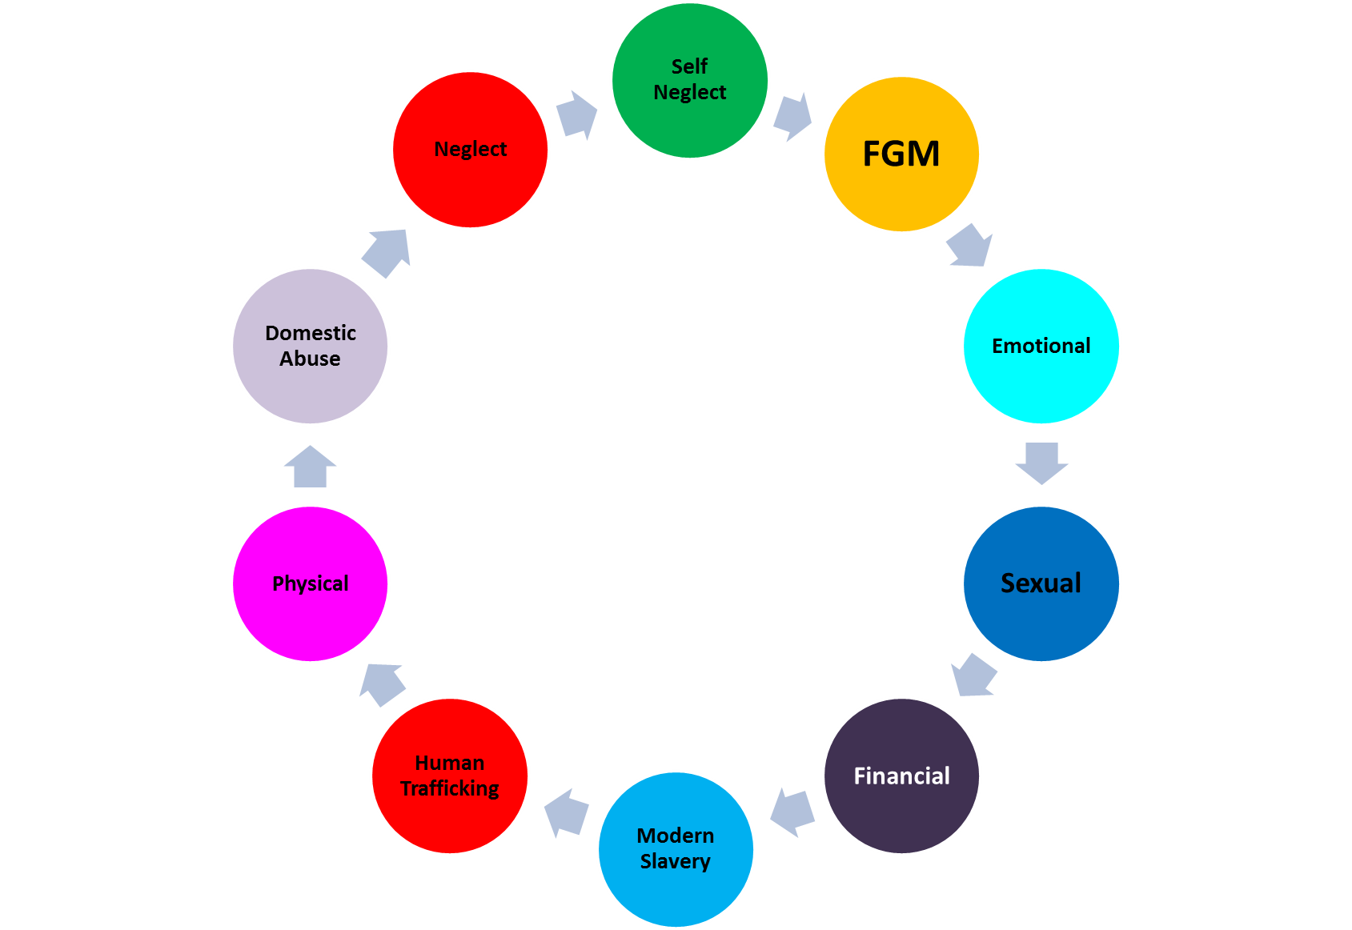

**Actions**

If you are concerned about the immediate safety of a child , adult or your safety **call 999.**

Lesser concerns discuss with your line manager

***Remember: The well-being and needs of a child must come first and have we all a duty to share information regarding safeguarding concerns with children’s services and /or the police.***

**Training Requirements:**

**Non-Clinical Staff** – Level 1 is covered as part of the core annual refresher

**Clinical Staff** - service specific sessions are provided throughout the year

**Adult ICTs/Community Hospitals**

½ day sessions 09:15 to 12:30 13:15 to 16:30

**Sexual Health**

½ day sessions 09:15 to 12:30 13:15 to 16:30

**Specialist Children’s Services**

½ day sessions 09:15 to 12:30 13:15 to 16:30

**Out of Hours, Urgent Care, Walk in Centre, Minor Injuries Unit**

½ day sessions 09:15 to 12:30 – **followed by 60 minutes of Medicines Management awareness**

Dates for all training sessions are bookable through the training admin team:

[workforcetraining@lincs-chs.nhs.uk](mailto:workforcetraining@lincs-chs.nhs.uk)

**Useful Resources**

See the Safeguarding section within Patient Safety page of the staff intranet.

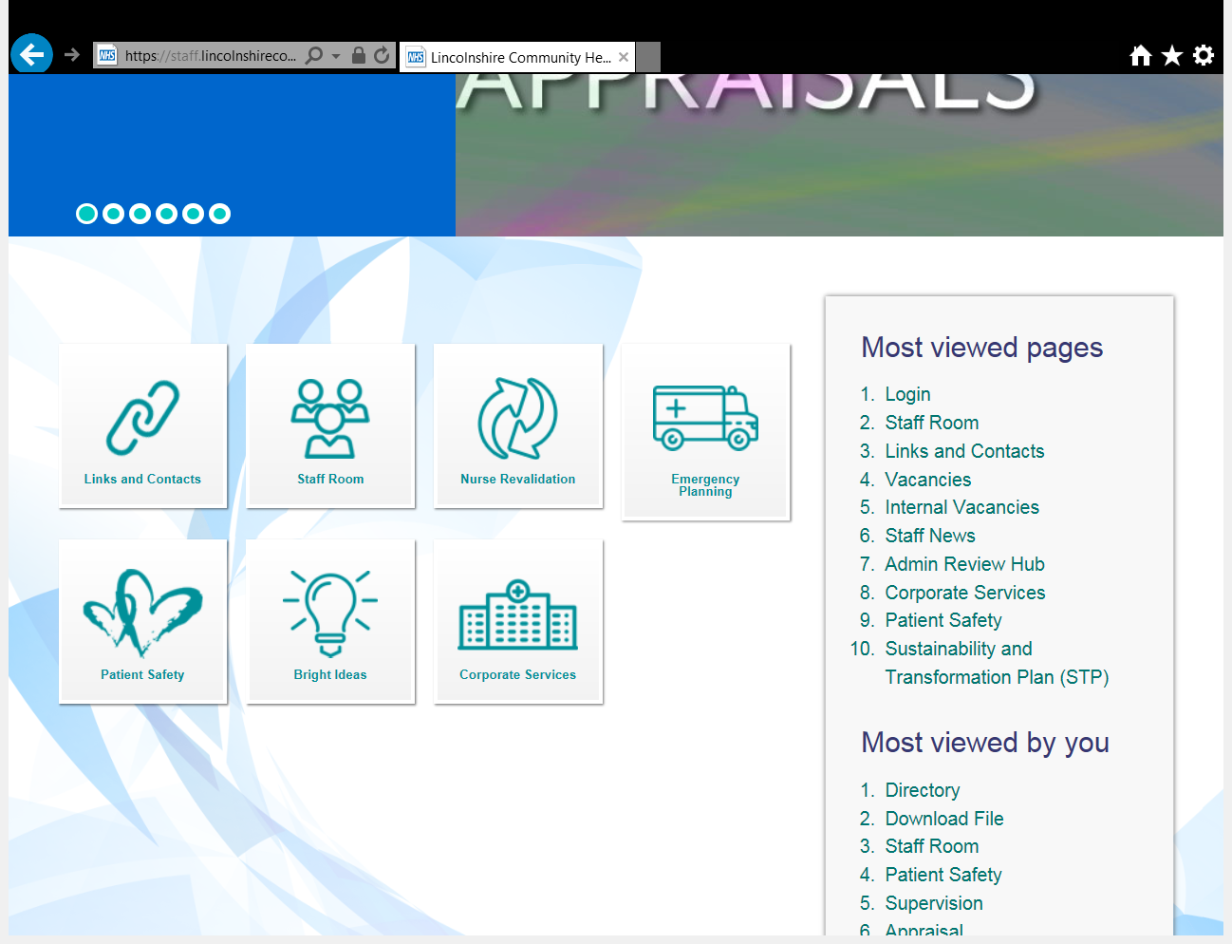

**Contact For Further Information:**

**LCHS Safeguarding Team**

**Head of Safeguarding**

Barbara Mitchell 01522 308947

**Named Nurse**

Gemma Cross 07818 421518

**Deputy Named Nurses**

Debbie Boulton 07785722953

Ali Balderstone 07900681430

**Administrators**

Ellie Titley 01522 308947

Louise Vowles 01522 308947

**Lincolnshire**

Customer Service Centre: 01522 782155

Adult Customer Service Centre – 01522 782155

<https://www.lincolnshire.gov.uk/residents/adult-care/safeguarding-adults/reporting-concerns/120500.article>

Children’s Safeguarding Customer Service Centre – 01522 782111

<https://www.lincolnshire.gov.uk/lscb/the-lscb/reporting-concerns/124627.article>

Emergency Duty Team – 01522 782333

**Peterborough**

Non Urgent Referrals – 01733 747474

Urgent Referrals – 01733 234724

Emergency Duty Team – 01733 234724

**Out of Hours (OOH’s)**

* LCHS on call duty Manager for supervision/advice-Telephone:01507 600100
* The Emergency Duty Team (EDT) for urgent concern and to make a referral to Child or Adult Social Care

Telephone: 01522 782333

*5pm-8.45am Monday – Thursday*

*4.45pm Friday until 8.45am Monday and 24hrs weekends and Banks Holidays*

* For staff working from Peterborough MIIU contact:

Peterborough Social Care Emergency Duty Team (EDT)-Telephone:01733 234724

**Section 14**

**Clinical Supervision:**

A workbook is available as an to introduction to clinical supervision which is available on the staff intranet

All clinical staff to undertake and record a minimum of one clinical supervision session every 3 months

Recording is via the trust’s electronic recording system

1.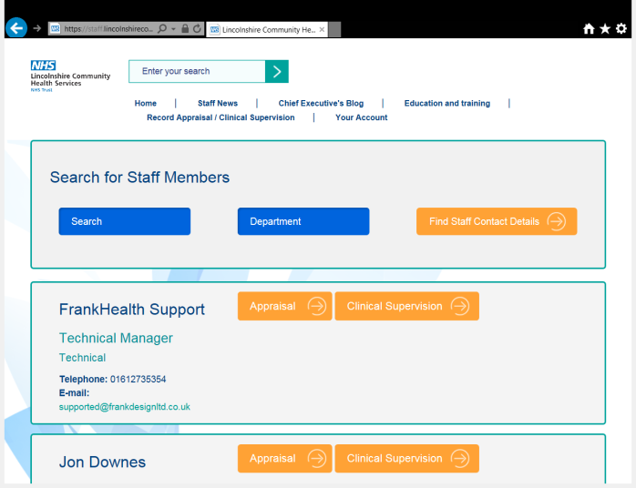 2. 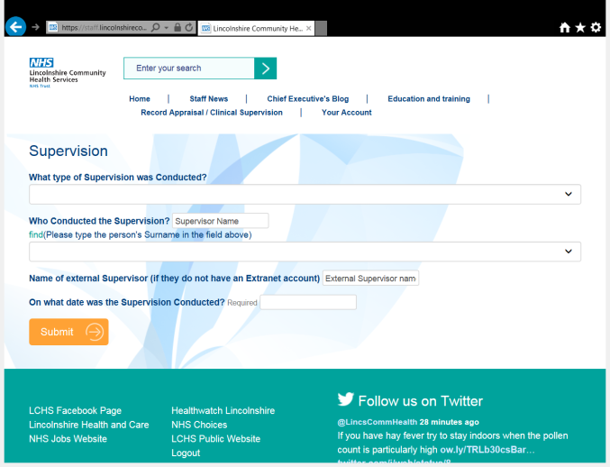

Email queries to: [kim.todd@lincs-chs.nhs.uk](mailto:kim.todd@lincs-chs.nhs.uk)

**Section 15**

**Medical Devices:**

**What Is a Medical Device?**

A “medical device” is, any instrument, apparatus, appliance, material or health care product, excluding drugs, used for, or by, a patient or service user for: -

* Diagnosis, prevention, monitoring, treatment or alleviation of disease.
* Diagnosis, monitoring, treatment, or alleviation of, or compensation for, an injury or impairment.
* Investigation, replacement, or modification of the anatomy or of a physiological process.
* Control of conception.

**Life Cycle of Equipment**

The life cycle of equipment refers to a method of managing equipment that takes into account every part of the life of the item. This extends from before purchase until after disposal. Please refer to the Medical Devices Policy and the How to Guides for more detail on how to effectively manage those devices that you use. The documents may be accessed via the Trust Staff Intranet pages. You are strongly encouraged to read these.

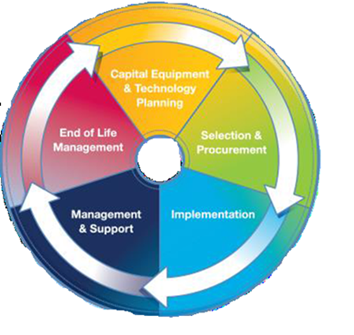

**Keeping Records**

Records management is an extremely important part of medical device management.

Each asset register holder needs to maintain an up to date and accurate list of all devices both in use and out of service.

Where a device has been loaned to a patient records must be maintained detailing patient demographics, any training provided to the patient, the date of loan and date that the device must be recalled for servicing etc.

Where devices are re-used the service must establish sufficient and appropriate decontamination methods and record keeping for the devic

**Training**

Before you use a piece of equipment it is essential that you have received adequate training and are deemed competent on its use. Please ask your line manager about your local training processes.

If you provide equipment for your patients to use it is vital that the patient or carer receives training and a copy of the user manual for that device AND that you are satisfied that the user has sufficient knowledge to operate the device safely.

**Reporting Incidents**

The Datix system may be used to report incidents involving medical devices however in some instances where the harm is serious or a catastrophic failure of the device occurs the MHRA also need to be involved. If you are unsure or need advice please refer to the Medical Devices How to Guide for Adverse incidents or contact a member of the Medical Devices Team or one of the Trusts Risk managers for advice.

**To re-use or not to re-use?**

****Single-use is the term used to describe any medical device intended to be used on an individual patient during a single procedure and then discarded. It is best practice and LCHS policy that a device designated as single-use must not be re-used. A single-use device is also not intended to be reprocessed and used again, even on the same patient.

*‘Do Not Re-use’ symbol:*

*The synonyms for this symbol are* ***“single use”*** *or* ***“use only once”***

**Need more help?**

**Meet the Medical Devices Team**

|  |  |  |
| --- | --- | --- |
| **Cheryl Day** |  | **Mo Bird** |
| Head of  Medical Devices and Technology |  | Medical Devices Officer |
| Rm 131 Trentside  John Coupland Hospital |  | Grace Swan Health Clinic  Spilsby |
| Mobile 078 2723 4385 |  | Mobile: 078 1131 5210 |
| [Cheryl.day@lincs-chs.nhs.uk](mailto:Cheryl.day@lincs-chs.nhs.uk) or  [Cheryl.day@nhs.net](mailto:Cheryl.day@nhs.net) |  | [Maureen.bird@lincs-chs.nhs.uk](mailto:Maureen.bird@lincs-chs.nhs.uk) |

**Section 16**

**Other Useful Rescources:**

**Staff Side:**

We are here to represent, support and negotiate for **all** the staff of LCHS.

Staff side works in partnership with the trust regularly meeting with management, HR and Workforce to ensure that all procedure and policies are being followed. We are involved in Job Matching, all LCHS consultations, QUIPP programme boards, policy ratification and we regularly attend a variety of meetings and are members of various committees. We can support you as an individual member of staff or as a collective. We work with management but our main objective is to support you!

**Counter Fraud:**

**Your Local Counter Fraud Specialist Team**

If you suspect a fraud or corruption may be taking place within or against the NHS, please contact the Local Counter Fraud Specialist Team in absolute confidence and they will be pleased to help you.

Neil Mohan Juliette Meek Gina Dosanjh Lekh

T: 01509 604 029 T: 01603 883099 T: (0) 1223 552333

E: [neil.mohan@nhs.net](mailto:neil.mohan@nhs.net) M: 07802 658845 E: [g.lekh@nhs.net](mailto:g.lekh@nhs.net)

E: [juliette.meek@nhs.net](mailto:juliette.meek@nhs.net)

Dominika Kortus

T: 07730 146 627

E: [dominika.kortus@nhs.net](mailto:dominika.kortus@nhs.net)

**NHS Fraud & Corruption reporting line: 0800 028 40 60**

[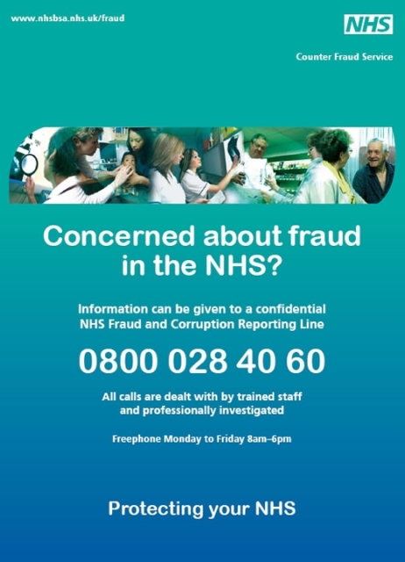](http://www.google.co.uk/url?sa=i&rct=j&q=&esrc=s&source=images&cd=&cad=rja&uact=8&ved=0ahUKEwj5moGcxN7VAhWGPBQKHWfEBAAQjRwIBw&url=http://www.wales.nhs.uk/sitesplus/862/page/52161&psig=AFQjCNHLJpoCULBDvmGW83_fCU952u8R6w&ust=1503068382639772)